# ABSTRACT

The project is aimed at designing a density based dynamic traffic signal system where the timing of signal will change automatically on sensing the traffic density at any junction. Traffic congestion is a severe problem in most cities across the world and therefore it is time to shift more manual mode or fixed timer mode to an automated system with decision making capabilities.

Present day traffic signalling system is fixed time based which may render inefficient if one lane is operational than the others. To optimize this problem, we have made a framework for an intelligent traffic control system. Sometimes higher traffic density at one side of the junction demands longer green time as compared to standard allotted time We, therefore propose here a mechanism in which the time period of green light and red light is assigned on the basis of the density of the traffic present at that time. This is achieved by using PIR (proximity Infrared sensors). Once the density is calculated, the glowing time of green light is assigned by the help of the microcontroller (Arduino). The sensors which are present on sides of the road will detect the presence of the vehicles and sends the information to the microcontroller (Arduino) where it will decide how long a flank will be open or when to change over the signal lights. In subsequent sections, we have elaborated the procedure of this framework.

# INTRODUCTION

In today’s high-speed life, traffic congestion becomes a serious issue in our day-to-day activities. It brings down the productivity of individual and thereby the society as lots of work hour is wasted in the signals. High volume of vehicles, the inadequate infrastructure and the irrational distribution of the signalling system are main reasons for these chaotic congestions. It indirectly also adds to the increase in pollution level as engines remain on in most cases, a huge volume of natural resources in forms of petrol and diesel is consumed without any fruitful outcome. Therefore, in order to get rid of these problems or at least reduce them to significant level, newer schemes need to be implemented by bringing in sensor-based automation technique in this field of traffic signalling system.

# 1.1 Objective of the Project:

Our project aims at reducing traffic congestion and unwanted long-time delay during the traffic light switch overs especially when the traffic is very low.

It is designed to be implemented in places nearing the junctions where the traffic signals are placed, in order to reduce the congestion in these junctions.

It keeps a track of the vehicles in each road and accordingly adjusts the time for each traffic light signals.

The higher the number of vehicles on the road the longer will be the time delay allotted for that corresponding traffic light signal.

The main purpose of this project is, if there will be no traffic on the other signal, one shouldn’t wait for that signal. The system will skip that signal and will move on the next one.

1.2 Present Traffic Signalling System

Under present scenario, traffic control is achieved by the use of a system of hand signs by traffic police personnel, traffic signals, and markings. A comparable and matching education program is needed, through driver-licensing authorities, to assure that those who operate motor vehicles understand the rules of the road and the actions that they are required or advised to take when a particular control device is present. Each traffic control device is governed by standards of design and usage; for example, stop signs always have a red background and are octagonal in shape.

Design standards allow the motorist to quickly and consistently perceive the sign in the visual field along the road. Standard use of colours and shape aids in this identification and in deciding on the appropriate course of action. Under current circumstances, traffic lights are set on in the different directions with fixed time delay, following a particular cycle while switching from one signal to other creating unwanted and wasteful congestion on one lane while the other lanes remain vacant.

The system we propose identify the density of traffic on individual lanes and thereby regulate the timing of the signals’ timing. IR sensors count the obstructions and provide an idea about the traffic density on a particular lane and feed this response to a controller unit which will make the necessary decisions as and when required.

# IDEA & METHODOLOGY

# 2.1 Idea

As we all know that traffic congestion is a major problem from a long time and traffic administration is also trying overcome this serious from a long time. So as a result, one solution has been deducted which is controlling the traffic on time delay. The basic idea of this paper has been taken from the foresaid concept. According to that idea the traffic signal switches after a certain interval of time. The time interval is controlled by any microcontroller.

This was a very basic step towards the optimization of traffic on road but this was not up to the mark. So, to control the traffic in smarter and more efficient way this project has been made by modifying the previous idea. The new idea is doing its job good as it has been seen that traffic jams are reduced and also the crucial time of the citizens are saved.

# 2.2 Methodology

* The system is based on microcontroller.
* The system contains IR transmitters and IR receivers which are mounted on the either side of roads.
* This IR system gets activated when any vehicle passes on road between IR transmitter and IR receiver.
* The microcontroller controls the IR system and gets activated when vehicles are passing in between the sensors.
* Based on different densities of vehicles, the microcontroller decides the glowing time of the traffic lights



**Basic Layout of Traffic Control System**

# 2.3 Limitations of this Circuit:

* IR sensors sometimes may absorb normal light also. As a result, traffic system works in improper way.
* IR sensors work only for fewer distances.
* We have to arrange IR sensors in accurate manner otherwise they may not detect the traffic density.

1. **SYSTEM COMPONENT**

**3.1 Software:**

The ATMega328p microcontroller IC with Arduino bootloader makes a lot of work easier in this project as Arduino code is written in C++ with an addition of special methods and functions, which we’ll mention later on. C++ is a human-readable programming language. When you create a ‘sketch’ (the name given to Arduino code files), it is processed and compiled to machine language.

The Arduino Integrated Development Environment (IDE) is the main text editing program used for Arduino programming. It is where you’ll be typing up your code before uploading it to the board you want to program. Arduino code is referred to as sketches.



**Arduino IDE**

**3.2 Hardware**

1. Arduino UNO
2. IR Sensors [4 units]
3. Battery 9V
4. Battery Caps
5. LED Lights
   1. Red LED [4 units]
   2. Yellow LED [4 units]
   3. Green LED [4 units]
6. Resistors [4 units]
7. Soldering iron
8. Soldering Wire
9. Connecting Wire

All the components are mounted on a 3D model of a 4-way road system where traffic light are installed. The model is an exact simulation of the real application and works as it should be according to the idea proposed in this project.

3.2.1 ARDUINO UNO

The Arduino Uno is a microcontroller board based on the ATmega328.It has 14 digital input/output pins (of which 6 can be used as PWM outputs), 6 analog inputs, a 16 MHz ceramic resonator, a USB connection, a power jack, an ICSP header, and a reset button. Arduino board designs use a variety of microprocessors and controllers.

The boards are equipped with sets of digital and analog input/output (I/O) pins that may be interfaced to various expansion boards or breadboards (shields) and other circuits. The boards feature serial communications interfaces, including Universal Serial Bus (USB) on some models, which are also used for loading programs from personal computers.

The microcontrollers are typically programmed using a dialect of features from the programming languages C and C++. In addition to using traditional compiler toolchains the Arduino project provides an integrated development environment (IDE) based on the Processing language project.

Most Arduino boards consist of an Atmel 8-bit AVR microcontroller (Atmega8, Atmega168, Atmega328, Atmega1280, Atmega2560) with varying amounts of flash memory, pins, and features. The 32-bit Arduino Due, based on the Atmel SAM3X8E was introduced in 2012. The boards use single or double-row pins or female headers that facilitate connections for programming and incorporation into other circuits. These may connect with add-on modules termed shields.

Multiple and possibly stacked shields may be individually addressable via an I²C serial bus. Most boards include a 5V linear regulator and a 16 MHz crystal oscillator or ceramic resonator. Some designs, such as the LilyPad, run at 8 MHz and dispense with the onboard voltage regulator due to specific form-factor restrictions.

Arduino microcontrollers are pre-programmed with a boot loader that simplifies uploading of programs to the on-chip flash memory. The default bootloader of the Arduino UNO is the optiboot bootloader Boards are loaded with program code via a serial connection to another computer.

Some serial Arduino boards contain a level shifter circuit to convert between RS-232 logic levels and transistor-transistor logic (TTL) level signals. Current Arduino boards are programmed via Universal Serial Bus (USB), implemented using USB-to-serial adapter chips such as the FTDI FT232. Some boards, such as later-model Uno boards, substitute the FTDI chip with a separate AVR chip containing USB-to-serial firmware, which is reprogrammable via its own ICSP header.

Other variants, such as the Arduino Mini and the unofficial Boarduino, use a detachable USB-to-serial adapter board or cable, Bluetooth, or other methods. When used with traditional microcontroller tools, instead of the Arduino IDE, standard AVR in-system programming (ISP) programming is used.

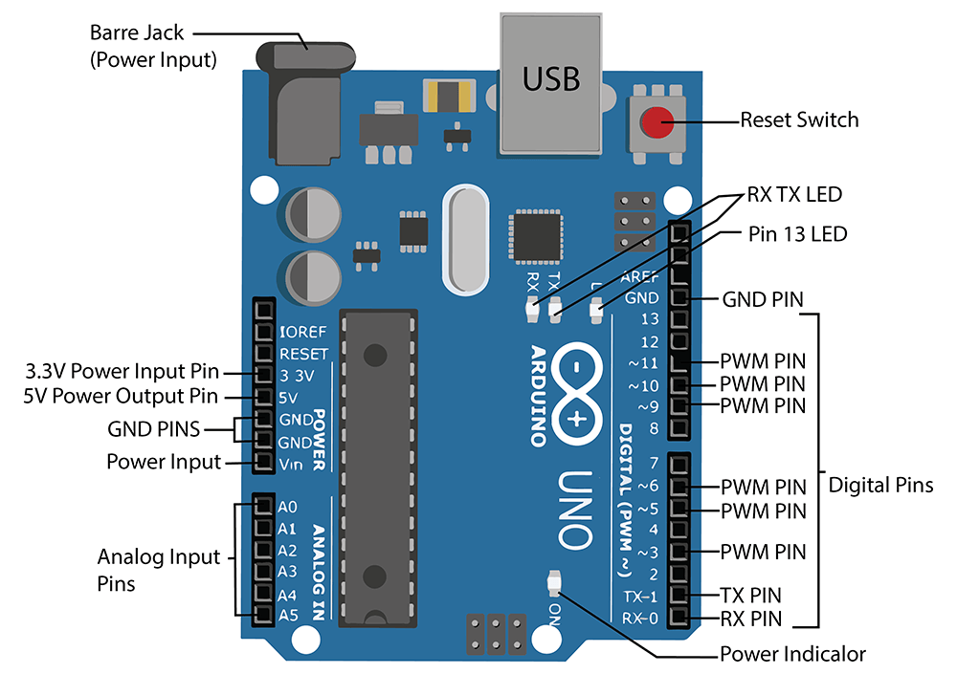

**Figure 3.3: Diagram of Arduino Uno**

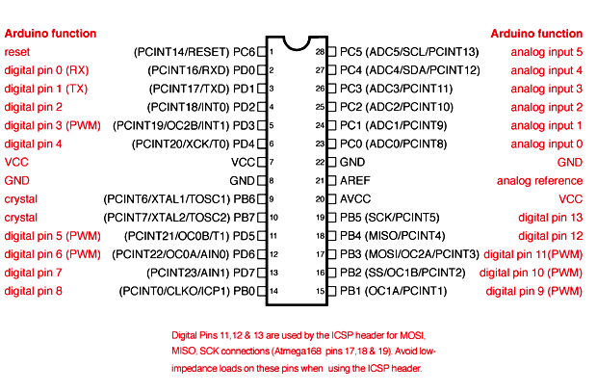

**Figure 3.4: PIN Layout of Arduino Uno**

Vin: The input voltage or Vin to the Arduino while it is using an exterior power supply opposite to volts from the connection of USB or else RPS (regulated power supply). By using this pin, one can supply the voltage.

5Volts: The RPS can be used to give the power supply to the microcontroller as well as components which are used on the Arduino board. This can approach from the input voltage through a regulator.

3V3: A 3.3 supply voltage can be generated with the onboard regulator, and the highest draw current will be 50 mA.

GND: GND (ground) pins

Memory:

The memory of an ATmega328 microcontroller includes 32 KB and 0.5 KB memory is utilized for the Boot loader), and also it includes SRAM-2 KB as well as EEPROM-1KB.

Input and Output:

We know that an arguing Uno R3 includes 14-digital pins which can be used as an input otherwise output by using the functions like pinMode(), digitalRead(), and digitalWrite(). These pins can operate with 5V, and every digital pin can give or receive 20mA, & includes a 20k to 50k ohm pull up resistor. The maximum current on any pin is 40mA which cannot surpass for avoiding the microcontroller from the damage. Additionally, some of the pins of an Arduino include specific functions.

Serial Pins:

The serial pins of an Arduino board are TX (1) and RX (0) pins and these pins can be used to transfer the TTL serial data. The connection of these pins can be done with the equivalent pins of the ATmega8 U2 USB to TTL chip.

External Interrupt Pins:

The external interrupt pins of the board are 2 & 3, and these pins can be arranged to activate an interrupt on a rising otherwise falling edge, a low-value otherwise a modify in value.

PWM Pins:

The PWM pins of an Arduino are 3, 5, 6, 9, 10, & 11, and gives an output of an 8-bit PWM with the function analog Write ().

SPI (Serial Peripheral Interface) Pins:

The SPI pins are 10, 11, 12, 13 namely SS, MOSI, MISO, SCK, and these will maintain the SPI communication with the help of the SPI library.

LED Pin:

An arguing board is inbuilt with a LED using digital pin-13. Whenever the digital pin is high, the LED will glow otherwise it will not glow.

TWI (2-Wire Interface) Pins:

The TWI pins are SDA or A4, & SCL or A5, which can support the communication of TWI with the help of Wire library.

AREF (Analog Reference) Pin:

An analog reference pin is the reference voltage to the inputs of an analog i/ps using the function like analog Reference().

Reset (RST) Pin:

This pin brings a low line for resetting the microcontroller, and it is very useful for using an RST button toward shields which can block the one over the Arduino R3 board.

Communication:

The communication protocols of an Arduino Uno include SPI, I2C, and UART serial communication.

UART:

An Arduino Uno uses the two functions like the transmitter digital pin1 and the receiver digital pin0. These pins are mainly used in UART TTL serial communication.

I2C:

An Arduino UNO board employs SDA pin otherwise A4 pin & A5 pin otherwise SCL pin is used for I2C communication with wire library. In this, both the SCL and SDA are CLK signal and data signal.

SPI Pins:

The SPI communication includes MOSI, MISO, and SCK.

MOSI (Pin11):

This is the master out slave in the pin, used to transmit the data to the devices

MISO (Pin12):

This pin is a serial CLK, and the CLK pulse will synchronize the transmission of which is produced by the master.

SCK (Pin13):

The CLK pulse synchronizes data transmission that is generated by the master. Equivalent pins with the SPI library is employed for the communication of SPI. ICSP (in-circuit serial programming) headers can be utilized for programming ATmega microcontroller directly with the boot loader.

## 3.2.2 IR-SENSOR:

An infrared sensor is an electronic device, that emits in order to sense some aspects of the surroundings. An IR sensor can measure the heat of an object as well as detects the motion. These types of sensors measure only infrared radiation, rather than emitting it that is called a passive IR sensor. Usually, in the infrared spectrum, all the objects radiate some form of thermal radiation. These types of radiations are invisible to our eyes, which can be detected by an infrared sensor. The emitter is simply an IR LED (Light Emitting Diode) and the detector is simply an IR photodiode that is sensitive to IR light of the same wavelength as that emitted by the IR LED. When IR light falls on the photodiode, the resistances and the output voltages will change in proportion to the magnitude of the IR light received.

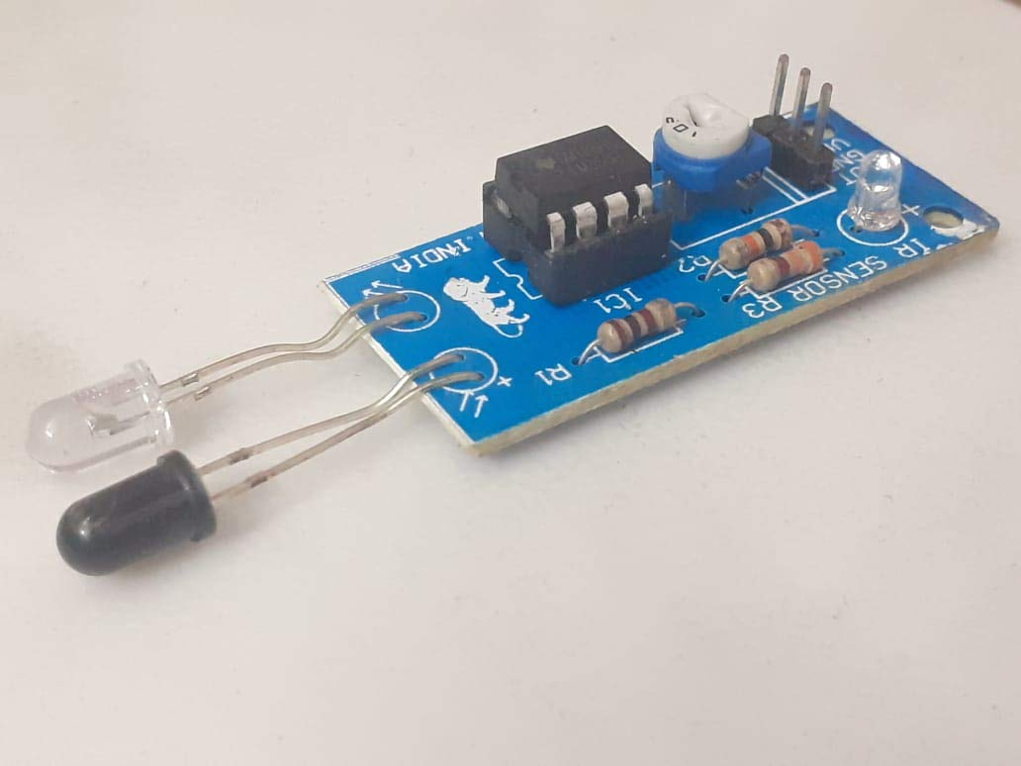

**Infrared (IR) Sensor**

An infrared sensor circuit is one of the basic and popular sensor modules in an electronic device. This sensor is analogous to human’s visionary senses, which can be used to detect obstacles and it is one of the common applications in real-time.

Types of IR Sensors

Infrared sensors can be passive or active. Passive infrared sensors are basically Infrared detectors. Passive infrared sensors do not use any infrared source and detects energy emitted by obstacles in the field of view. They are of two types: quantum and thermal. Thermal infrared sensors use infrared energy as the source of heat and are independent of wavelength. Thermocouples, pyroelectric detectors and bolometers are the common types of thermal infrared detectors.

Quantum type infrared detectors offer higher detection performance and are faster than thermal type infrared detectors. The photosensitivity of quantum type detectors is wavelength dependent. Quantum type detectors are further classified into two types: intrinsic and extrinsic types. Intrinsic type quantum detectors are photoconductive cells and photovoltaic cells.

Active infrared sensors consist of two elements: infrared source and infrared detector. Infrared sources include an LED or infrared laser diode. Infrared detectors include photodiodes or phototransistors. The energy emitted by the infrared source is reflected by an object and falls on the infrared detector.

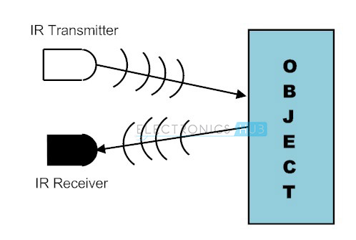

**Working of an IR-sensor**

IR Transmitter:

Infrared Transmitter is a light emitting diode (LED) which emits infrared radiations. Hence, they are called IR LED’s. Even though an IR LED looks like a normal LED, the radiation emitted by it is invisible to the human eye.

There are different types of infrared transmitters depending on their wavelengths, output power and response time.

A simple infrared transmitter can be constructed using an infrared LED, a current limiting resistor and a power supply.

When operated at a supply of 5V, the IR transmitter consumes about 3 to 5 mA of current. Infrared transmitters can be modulated to produce a particular frequency of infrared light. The most commonly used modulation is OOK (ON – OFF – KEYING) modulation.

IR transmitters can be found in several applications. Some applications require infrared heat and the best infrared source is infrared transmitter. When infrared emitters are used with Quartz, solar cells can be made.

IR Receiver:

Infrared receivers are also called as infrared sensors as they detect the radiation from an IR transmitter. IR receivers come in the form of photodiodes and phototransistors. Infrared Photodiodes are different from normal photo diodes as they detect only infrared radiation.

Different types of IR receivers exist based on the wavelength, voltage, package, etc. When used in an infrared transmitter – receiver combination, the wavelength of the receiver should match with that of the transmitter.

It consists of an IR phototransistor, a diode, a MOSFET, a potentiometer and an LED. When the phototransistor receives any infrared radiation, current flows through it and MOSFET turns on. This in turn lights up the LED which acts as a load. The potentiometer is used to control the sensitivity of the phototransistor.



**IR sensor module without its transmitter and receiver**

There are other applications of this module in which we do not need a transmitter and a receiver where we can connect any other sensor like LDR, Rain sensor PCB, and much more.

This module has its variety of uses that are not related to infrared sensing only but can be of any type because it consists of IC LM358 which is a great, low power and easy to use dual channel op-amp IC.

LM 358 has a lot of real-life applications e.g. Operational Amplifier (Op-amp) circuits, transducer amplifiers, DC gain blocks, etc. LM-358 is available in as small size as chip. It is the most commonly used device due to its cost-efficiency.

## 3.2.3 9 V BATTERY:

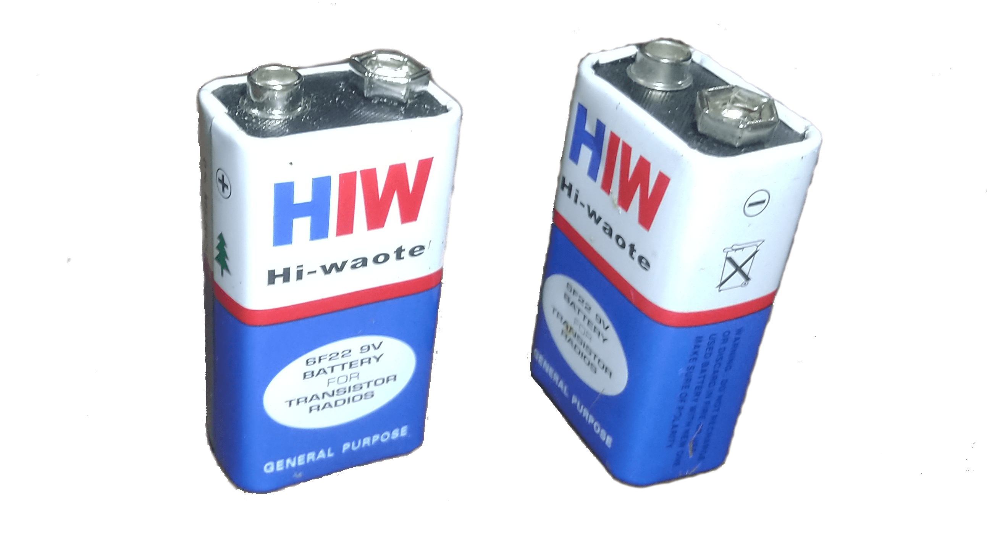The nine-volt battery, or 9-volt battery, is a common size of battery that was introduced for the early transistor radios. It has a rectangular prism shape with rounded edges and a polarized snap connector at the top. This type is commonly used in walkie-talkies, clocks and smoke detectors.

**9V Battery**

3.2.4 LED Light:

A light-emitting diode (LED) is a semiconductor light source that emits light when current flows through it. Electrons in the semiconductor recombine with electron holes, releasing energy in the form of photons. The color of the light (corresponding to the energy of the photons) is determined by the energy required for electrons to cross the band gap of the semiconductor. White light is obtained by using multiple semiconductors or a layer of light-emitting phosphor on the semiconductor device.

Appearing as practical electronic components in 1962, the earliest LEDs emitted low-intensity infrared (IR) light. Infrared LEDs are used in remote-control circuits, such as those used with a wide variety of consumer electronics. The first visible-light LEDs were of low intensity and limited to red. Modern LEDs are available across the visible, ultraviolet (UV), and infrared wavelengths, with high light output.

Early LEDs were often used as indicator lamps, replacing small incandescent bulbs, and in seven-segment displays. Recent developments have produced high-output white light LEDs suitable for room and outdoor area lighting. LEDs have led to new displays and sensors, while their high switching rates are useful in advanced communications technology.

LEDs have many advantages over incandescent light sources, including lower energy consumption, longer lifetime, improved physical robustness, smaller size, and faster switching. LEDs are used in applications as diverse as aviation lighting, fairy lights, automotive headlamps, advertising, general lighting, traffic signals, camera flashes, lighted wallpaper, horticultural grow lights, and medical devices.

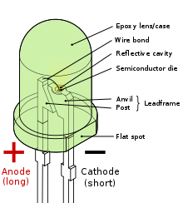

Mixing red, green, and blue sources to produce white light needs electronic circuits to control the blending of the colors. Since LEDs have slightly different emission patterns, the color balance may change depending on the angle of view, even if the RGB sources are in a single package, so RGB diodes are seldom used to produce white lighting. Nonetheless, this method has many applications because of the flexibility of mixing different colors, and in principle, this mechanism also has higher quantum efficiency in producing white light.

There are several types of multicolor white LEDs: di-, tri-, and tetrachromatic white LEDs. Several key factors that play among these different methods include color stability, color rendering capability, and luminous efficacy. Often, higher efficiency means lower color rendering, presenting a trade-off between the luminous efficacy and color rendering. For example, the dichromatic white LEDs have the best luminous efficacy (120 lm/W), but the lowest color rendering capability. Although tetrachromatic white LEDs have excellent color rendering capability, they often have poor luminous efficacy. Trichromatic white LEDs are in between, having both good luminous efficacy and fair color rendering capability.

One of the challenges is the development of more efficient green LEDs. The theoretical maximum for green LEDs is 683 lumens per watt but as of 2010 few green LEDs exceed even 100 lumens per watt. The blue and red LEDs approach their theoretical limits.

Dimming a multicolor LED source to match the characteristics of incandescent lamps is difficult because manufacturing variations, age, and temperature change the actual color value output. To emulate the appearance of dimming incandescent lamps may require a feedback system with color sensor to actively monitor and control the color.

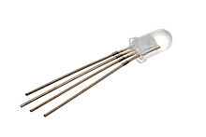

**A RGB LED**

3.2.5 Resistor:

10k resistor color code is as shown in the image it is brown/black/orange/gold, color code of resistors does not depend on the power rating of resistor, the power rating of the resistor depends on its physical size and comes under standard wattage rating of 1/4 W,1/2W,1W,10W, etc.



**Carbon Resistor**

Resistors are made from a mixture of carbon black or powdered graphite clay and resin binder the mixture is molded into the rods by compression or heating and then wire leads are fixed at the ends. Such registers are called carbon composition resistors.

## 3.2.6 BATTERY CAP:

The battery has both terminals in a snap connector on one end. The smaller circular (male) terminal is positive, and the larger hexagonal or octagonal (female) terminal is the negative contact. The connectors on the battery are the same as on the load device; the smaller one connects to the larger one and vice versa.

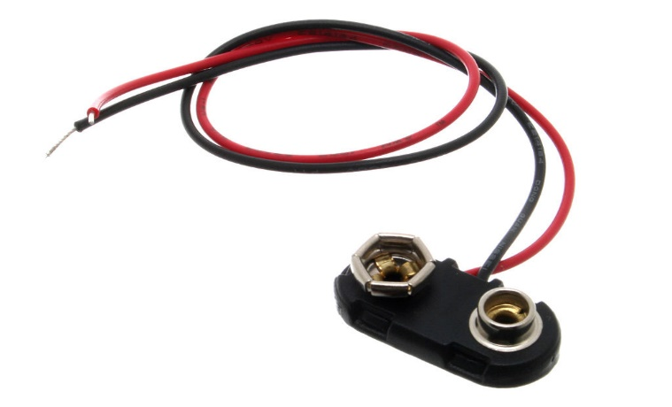

**Battery Cap**

3.2.7 Soldering Iron:

A soldering iron is a hand tool used in soldering. It supplies heat to melt solder so that it can flow into the joint between two workpieces. A soldering iron is composed of a heated metal tip and an insulated handle.

The basic purpose of a soldering iron is to create a bond between two workpieces using electronically heated soft metal (i.e., the solder). The soldering iron supplies heat to the soldering tip, which is used to melt the solder. The melted solder forms a bond in the joint between two workpieces.

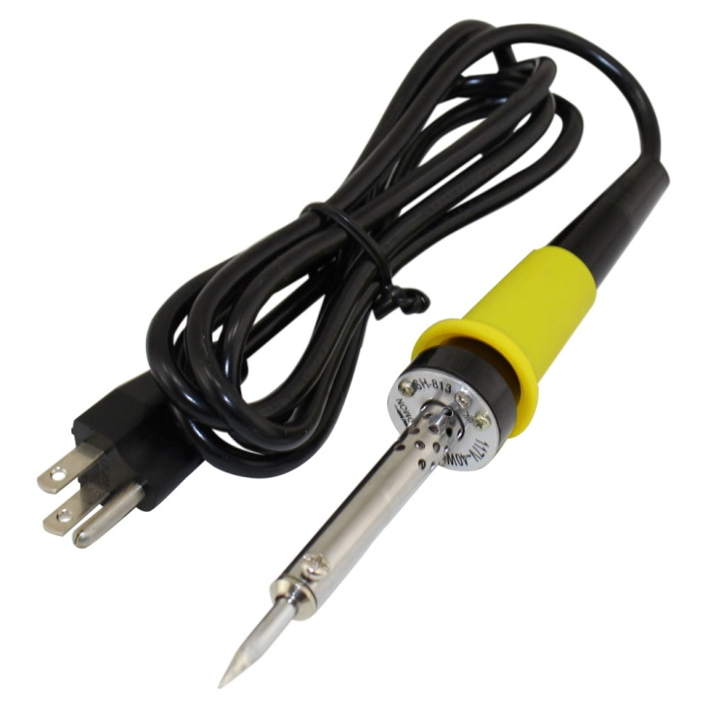

**soldering iron**

3.2.8 Solder Wire:

Solder is a fusible alloy used to join less fusible metals or wires, etc. Solder wire is comprised of different alloys, or of pure tin. Each metal requires a certain type of soldering wire to create strong bonds, because the combinations of metals that comprise soldering wire melt at different temperatures.

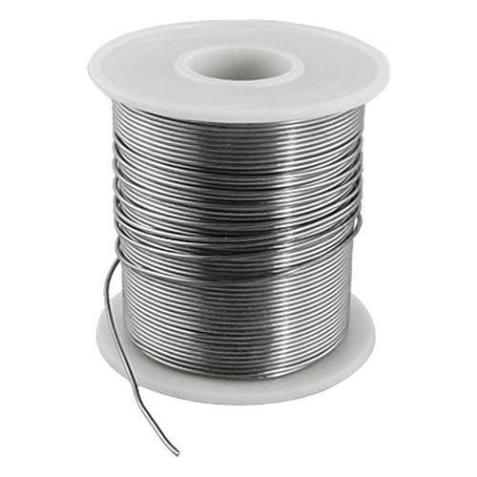

**Solder Wire**

3.2.9 Connecting Wire:

Connecting wires allows an electrical current to travel from one point on a circuit to another because electricity needs a medium through which it can move. Most of the connecting wires are made up of copper or aluminium. Copper is cheap and good conductivity.

The Function of Connecting Wires. Connecting wires provide a medium to an electrical current so that they can travel from one point on a circuit to another. In the case of computers, wires are embedded into circuit boards to carry pulses of electricity.

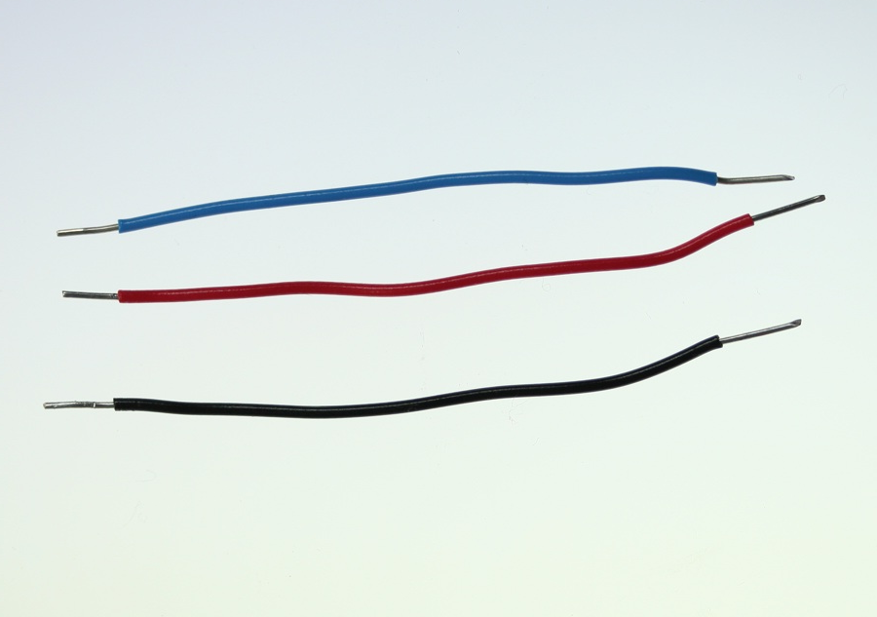

**connecting wire**

# CONSTRUCTION AND WORKING

The model works on the principle of changing of Traffic signals based on the density through an assigned section of the road. There are four sensors placed at four sides of a four-way road which checks the density of the area covered by the sensors.

Here we are using IR sensors to design an intelligent traffic control system. In order to measure the density of traffic on each side, IR sensors will be kept on either side of the road at a specific distance. Each of the IR sensors consists of an IR transmitter and an IR receiver. Just as the name suggests, the IR transmitter transmits the IR rays and the receiver is responsible to receive the rays. The whole system is controlled by the microcontroller which is the Arduino UNO.

# 4.1 Block Diagram



The working of the project is divided into three steps:

* If there is traffic at all the signals, then the system will work normally by controlling the signals one by one.
* If there is no traffic near a signal, then the system will skip this signal and will move on to the next one. For example, if there is no vehicle at signal 2, 3 and currently the system is allowing vehicles at signal 1 to pass. Then after signal 1, the system will move on to signal 4 skipping signal 2 and 3.
* If there is no traffic at all the 4 signals, then also the system will work normally by controlling the signals one by one.

In this way we can control the heavy traffic of any particular lane in peak timing like office hour.

But it has some very big drawbacks in which one of the drawbacks is the lane in which traffic is low have to wait for long time.

# 4.2 Circuit Diagram

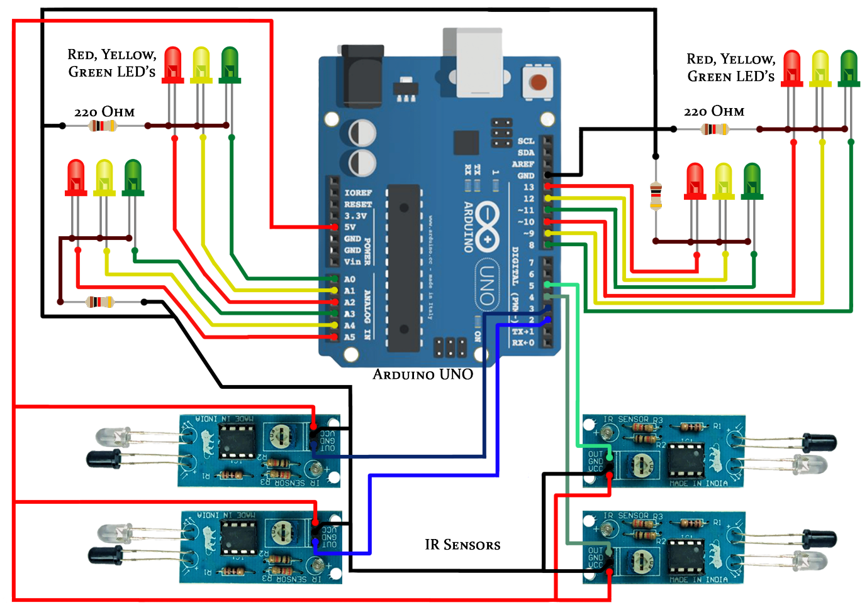

# 4.3 Code

#define red1 13

#define yellow1 12

#define green1 11

#define red2 10

#define yellow2 9

#define green2 8

#define red3 7

#define yellow3 6

#define green3 5

#define red4 4

#define yellow4 3

#define green4 2

#define sensor1 14

#define sensor2 15

#define sensor3 16

#define sensor4 17

#define sensor5 18

#define yellowLightTime 2000

#define greenLightTime 5000

#define sensorCheckTime 5000

int line=0;

void setup()

{

for (int i = 0; i < 14; i++)

{

pinMode(i, OUTPUT);

}

for(int i=14;i<20;i++)

{

pinMode(i, INPUT_PULLUP);

}

// int tickEvent = t.every(2000, doSomething);

digitalWrite(red2, HIGH);

digitalWrite(red3, HIGH);

digitalWrite(red4, HIGH);

}

void loop()

{

if(digitalRead(sensor1) == 1)

line=0;

else if(digitalRead(sensor2) == 1)

line=1;

else if(digitalRead(sensor3) == 1)

line=2;

else if(digitalRead(sensor4) == 1)

line=3;

else if(digitalRead(sensor5) == 1)

line=4;

traffic(line);

line++;

if(line == 5)

line=0;

}

void traffic(int line)

{

switch(line)

{

case 0:

digitalWrite(red1, LOW);

digitalWrite(yellow1, LOW);

digitalWrite(green1, HIGH);

Delay(greenLightTime);

digitalWrite(green1, LOW);

digitalWrite(yellow1, HIGH);

Delay(yellowLightTime);

digitalWrite(yellow1, LOW);

digitalWrite(red1, HIGH);

break;

case 1:

digitalWrite(red2, LOW);

digitalWrite(yellow2, LOW);

digitalWrite(green2, HIGH);

Delay(greenLightTime);

digitalWrite(green2, LOW);

digitalWrite(yellow2, HIGH);

Delay(yellowLightTime);

digitalWrite(yellow2, LOW);

digitalWrite(red2, HIGH);

break;

case 2:

digitalWrite(red3, LOW);

digitalWrite(yellow3, LOW);

digitalWrite(green3, HIGH);

Delay(greenLightTime);

digitalWrite(green3, LOW);

digitalWrite(yellow3, HIGH);

Delay(yellowLightTime);

digitalWrite(yellow3, LOW);

digitalWrite(red3, HIGH);

break;

case 3:

digitalWrite(red4, LOW);

digitalWrite(yellow4, LOW);

digitalWrite(green4, HIGH);

Delay(greenLightTime);

digitalWrite(green4, LOW);

digitalWrite(yellow4, HIGH);

Delay(yellowLightTime);

digitalWrite(yellow4, LOW);

digitalWrite(red4, HIGH);

break;

case 4:

digitalWrite(red1, LOW);

digitalWrite(yellow1, LOW);

digitalWrite(green1, HIGH);

Delay(greenLightTime);

digitalWrite(green1, LOW);

digitalWrite(yellow1, HIGH);

Delay(yellowLightTime);

digitalWrite(yellow1, LOW);

digitalWrite(red1, HIGH);

break;

}

}

/* void doSomething()

{

if(digitalRead(strLight1))

{

digitalWrite(light1, HIGH);

}

else

{

digitalWrite(light1, LOW);

}

if(digitalRead(strLight2))

{

digitalWrite(light2, HIGH);

}

else

{

digitalWrite(light2, LOW);

}

}*/

void Delay(int Time)

{

for(int i=0;i<Time;i++)

{

// t.update();

delay(1);

}

}

///////////////////////////////////////////////////////////////////////////////////////////////////////////////////////////////////

# 4.4 Code Explained

Three sets of LEDs via Green, Yellow and Red are used to indicate the GO state, Ready to Go state and WAIT state. The traffic signal will be tuned with a default timing of 10 seconds of green light and all other signal will be red. After 10 seconds two signals will be yellow for 4 seconds and another two will be red. This condition will be followed till all the IR sensors receiving the signals or all the IR sensors are not getting signals. The LEDs G (green), Y (yellow) and R (red) glow in following sequence.

* G1-R2-R3-R4
* Y1-Y2-R3-R4
* R1-G2-R3-R4
* R1-Y2-Y3-R4.
* R1-R2-G3-R4
* R1-R2-Y3-Y4
* R1-R2-R3-G4
* Y1-R2-R3-Y4

i.e., timing-based traffic signal will be automatically implemented when all the signals having same condition.

When condition changes, let us suppose when first side traffic signal is green and at that time third side traffic signal’s IR sensor receiving data then after first traffic signal it will automatically shifts towards third traffic signal without moving to second traffic signal.

* G1-R2-R3-R4
* Y1-R2-Y3-R4
* R1-R2-G3-R4

Similarly, let green light is on in the fourth traffic signal for 10 seconds and during that time second traffic signal’s IR sensor receiving data then after green light it will take 4 seconds delay for yellow light or we can say that the delay for pedestrians to walk in order to ensure their safety and then it will automatically shift towards second traffic signal.

* R1-R2-R3-G4
* R1-Y2-R3-Y4
* R1-G2-R3-R4

Just taking into consideration the above conditions further and let us suppose after second signal again forth signal’s IR sensor receiving data then after 10 seconds and 4 seconds delay signal is green for forth lane.

* R1-G2-R3-R4
* R1-Y2-R3-Y4
* R1-R2-R3-G4

# FUTURE SCOPE

This project can be extended by using Sound sensors (if the noise from other vehicles is eliminated), priority can be given to the sound sensor than the IR sensor and this will indicate the presence of ambulance and fire engine.

As part of future advancements, the traffic check post may be connected by wireless transmitters by which the crossings ahead may be an anticipation of the traffic that is approaching. This may be achieved the connecting the sensor network with GPS connectivity and short-wave radio transmission signals. This will act as a feed forward system making the signalling system even more smooth and congestion free.

We will also update this system with modern technology so that when a vehicle tries to move even during red signal it will turn on an alarm to warn the driver of the vehicle and will send the alert to the traffic warden with the picture.

# CONCLUSION

The circuits when implemented separately works as per the desired output however during integrating all, output fluctuates and shows different response every time. This could be a problem of loose connections of the wires or internal wiring of the bread board used. This project lists down the results realized from the practical work and examines whether ideas / solution approaches recommended in research are met by the practical implementation. For this project the main communication is by using IR technology.

From the series of experiments, we have conducted the following results were obtained:

* Traffic can be cleared without any irregularities
* Time can be shared evenly for all intersections
* Effective time management

Density of the road is calculated using IR sensors. IR sensors are used to detect the number of vehicles based on the IR sensor, the traffic light is operated.IR sensors are less cost and more effective.

There is exigent need of efficient traffic management system in our country, as India meets with 384 road accidents every day. To reduce this congestion and unwanted time delay in traffic an advanced system is designed here in this project. With field application of this technology, the maddening chaos of traffic can be effectively channelized by distributing the time slots based on the merit of the vehicle load in certain lanes of multi junction crossing. We have successfully implemented the prototype at laboratory scale with remarkable outcome. The next step forward is to implement this schema is real life scenario for first hand results, before implementing it on the largest scale. We believe that this may bring a revolutionary change in traffic management system on its application in actual field environment.